|  |
| --- |
| **.** |
| The Impact of Foreclosure Waves on the City of Baltimore |
| Peter Rosenblatt & Katherine Newman |
|  |
| **Krieger School of the Arts and Sciences, Johns Hopkins University** |
| **3/7/2011** |

|  |
| --- |
|  |

**The Impact of Foreclosure Waves on Baltimore**

**Summary**

The past three years has seen a wave of foreclosures land on families and neighborhoods throughout the city of Baltimore. Altogether, foreclosures **cost Baltimore families more than $1.5 billion between 2008 and 2010; the average family lost almost $150,000.** In addition to the damage foreclosure did to individuals and families, the city itself was a victim because property taxes that would otherwise have helped to support the public sector went uncollected. In 2010 alone, we estimate that the **city lost $13.6 million in property taxes**. This figure is almost certainly an underestimate of the total loss to the city, because it does not take into account the negative impact that proximity to a foreclosed house has on property values of other homes in the neighborhood.

Virtually every neighborhood—from middle class communities like Hamilton, to working class areas in west Baltimore, to the redeveloping neighborhoods around Patterson Park – has been affected, and few have been left untouched. Overall, middle and working class neighborhoods saw a greater impact: homes in these neighborhoods were more than twice as likely to be foreclosed upon as homes in the city’s wealthy neighborhoods. Although majority white neighborhoods had a lower incidence of foreclosure than majority black neighborhoods, mixed-race areas actually saw the highest incidence, with more than 6% of occupied homes in the average mixed race neighborhood experiencing a foreclosure. Areas in the midst of renewal, like Washington Village or north Patterson Park, were particularly hard hit, with more than one out of every 10 homes foreclosed. In the neighborhood north of Patterson Park, foreclosures occurred on just about every street, and many blocks had multiple houses that families lost to foreclosure.

Between 2007 and 2010, there were more than 18,000 foreclosures in Baltimore. The number of foreclosures rose from a low in the second quarter of 2008 to an overall peak in April- June of 2010, a three month period during which there were more than 2,000; twice as many as there had been at the start of 2007. In the analysis below, we look more closely at those foreclosures which took place between 2008 and 2010.

**The Big Picture**

A foreclosure filing is a legal action in the Baltimore City Circuit Court, representing the initiation of a legal procedure by a lending agency to reclaim the title to a property due to non-payment on a mortgage loan. Not all filings result in actual foreclosures. Under Maryland law, foreclosure fillings take place no sooner than 90 days after the loan is in default.[1]

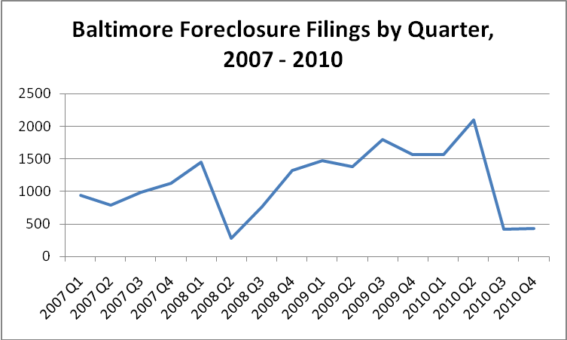

Foreclosures increased steadily from the second half of 2008 through the middle of 2010. The second quarter of 2010 saw the peak of foreclosures in the city, at more than 2,000. This was more than double the number of foreclosure filings than in the beginning of 2007.

To understand the impact of the problem on Baltimore neighborhoods, we analyzed **11,188** foreclosure filings that took place within the city of Baltimore between January of 2008 and December of 2010[2].

**Who Lost? The Disparate Impact of Foreclosures**

**Almost Every neighborhood in Baltimore was touched by the foreclosure crisis.** 194 of 200 census tracts in the city experienced at least one foreclosure, for an average of 58 per tract or 5.2% of its occupied housing stock. But averages can be misleading, since the variation in impact is considerable. On the low end, only 0.35% of occupied houses went into foreclosure proceedings; at the high end, the proportion was 18%. Communities in which home owners are more vulnerable to unemployment or that are serviced by lenders offering less favorable mortgage terms, are more vulnerable to foreclosure. They are not necessarily the very poorest neighborhoods because the poor are less likely to be home owners in the first place. The “high impact” neighborhoods are, however, likely to be among the least affluent home owners.

**Poorer, mixed race neighborhoods had a higher incidence of foreclosure than well-off majority white neighborhoods.** The average white neighborhood had 44 foreclosures, less than 4% of its occupied housing stock. The average mixed race neighborhood had 68 foreclosures, more than 6% of its occupied housing stock. Majority black neighborhoods were more like mixed race neighborhoods, with 5.4 % of their houses foreclosed.

Affluent neighborhoods (where the median household income was more than $95,000) saw less than 2% of their houses foreclosed. Working and middle class neighborhoods were much more likely to experience foreclosure, with incidence rates more than twice as high. *Please see Technical Appendix for definition of class.*

Moderate to high poverty neighborhoods (with poverty rates between 20 and 40%) had a higher incidence of foreclosure than lower poverty neighborhoods, at 6% of occupied houses.Very high poverty neighborhoods did not have as high an incidence of foreclosure, which is almost certainly due to the higher percentage of renters they contain. In Baltimore, high poverty neighborhoods are 73% renter occupied on average, compared to low poverty neighborhoods that are only 32% renter occupied. Majority black neighborhoods also have a higher percentage of renters (54% on average) than majority white neighborhoods (39% on average).

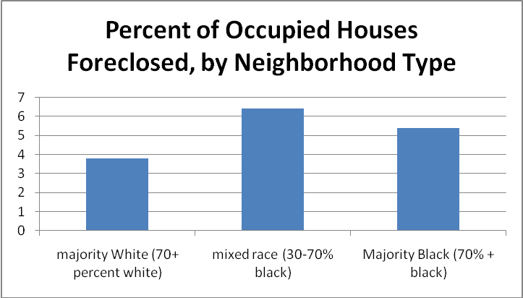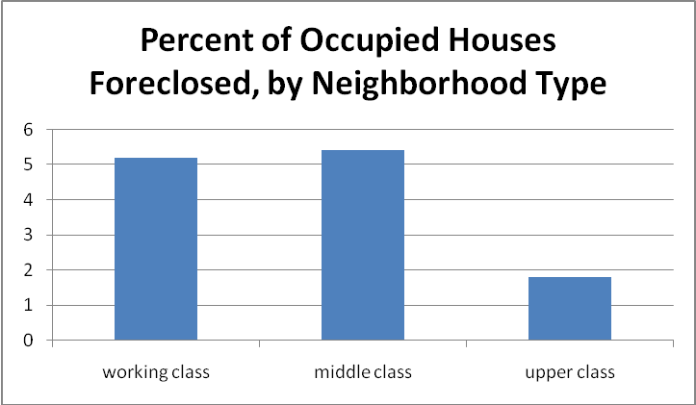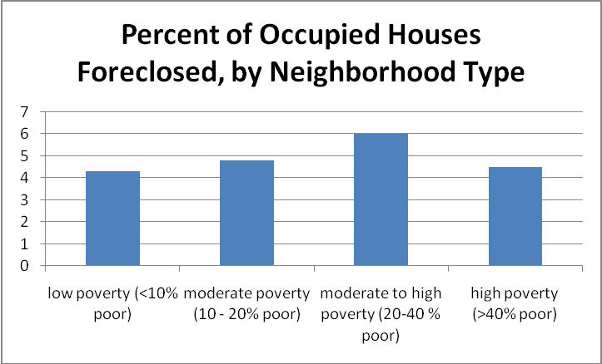

**The Geography of Foreclosure**

Given the disparate impact of foreclosure by income, it comes as no surprise that the geographic distribution of the “waves” is uneven. As **MAP 1** makes clear, the west and northeast areas of the city saw 5-10% of their occupied housing stock go into foreclosure. The highest incidences in the city are in the Washington Village area in the southwest and the area north and east of Patterson Park. By contrast, Midtown and the Roland Park/Mt. Washington areas of the city were the least affected by the foreclosure crisis.

**Map 1**

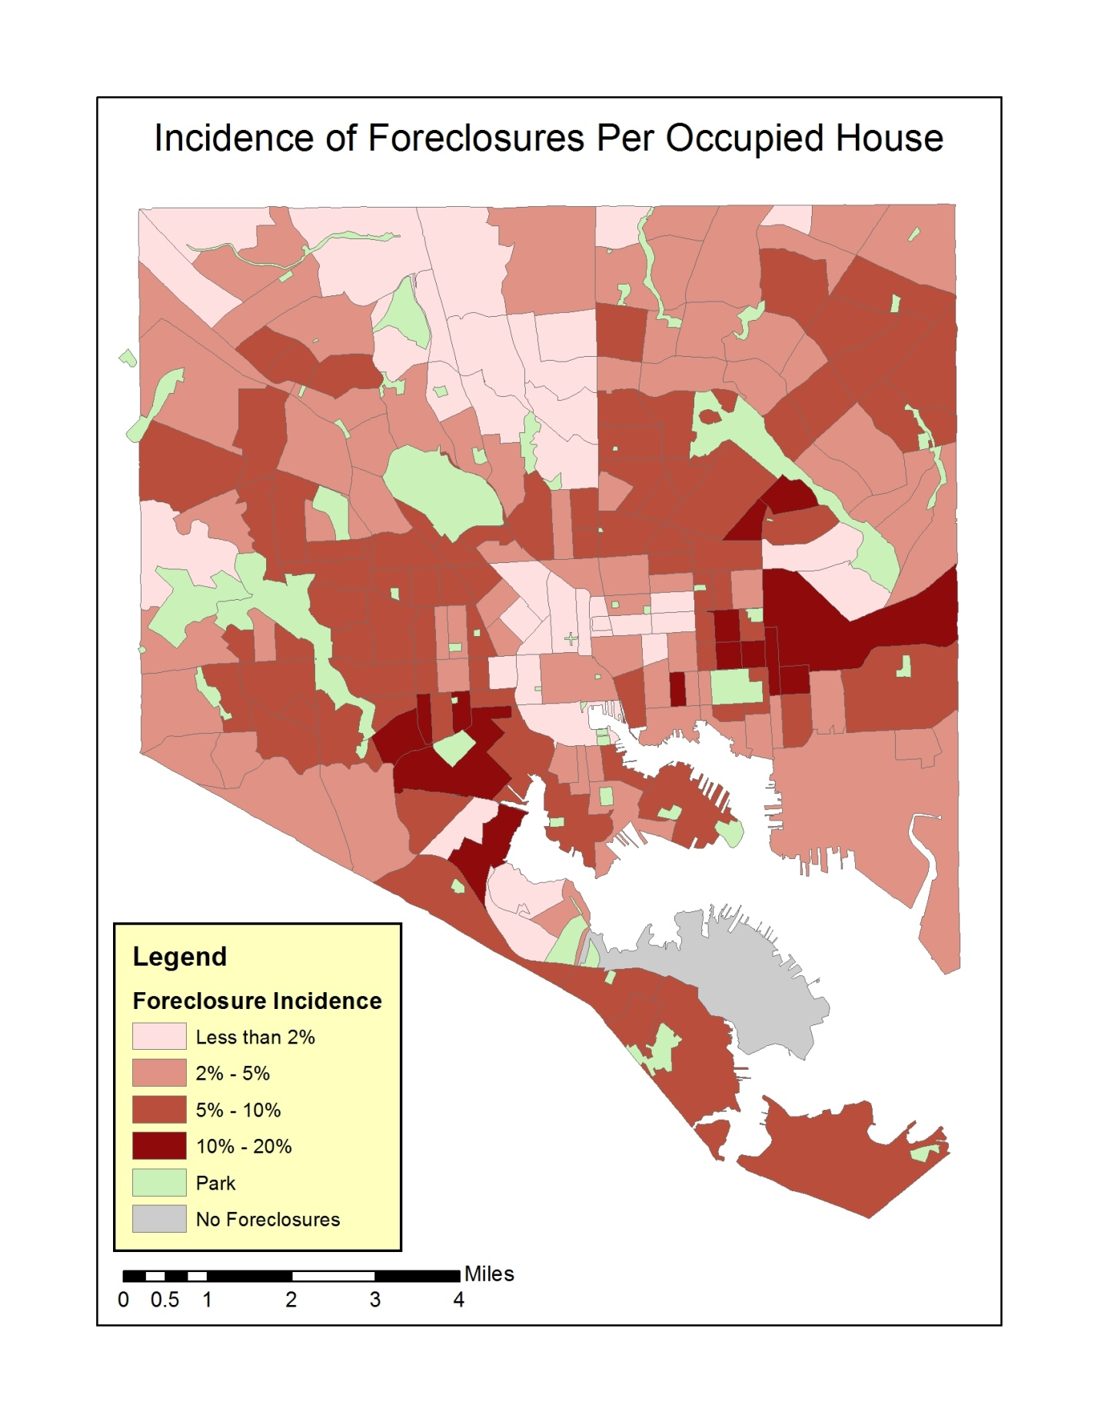

**MAP 2a** illustrates the relationship between neighborhood income and foreclosure. Each yellow dot represents one foreclosure. The background ofthe map shows the median household income in the census tracts. There are only a scattered few foreclosures in the city’s wealthiest neighborhoods in the north-center region, although there are more in the upper-middle class neighborhoods along the waterfront (Canton and Federal Hill).

**Map 2a**

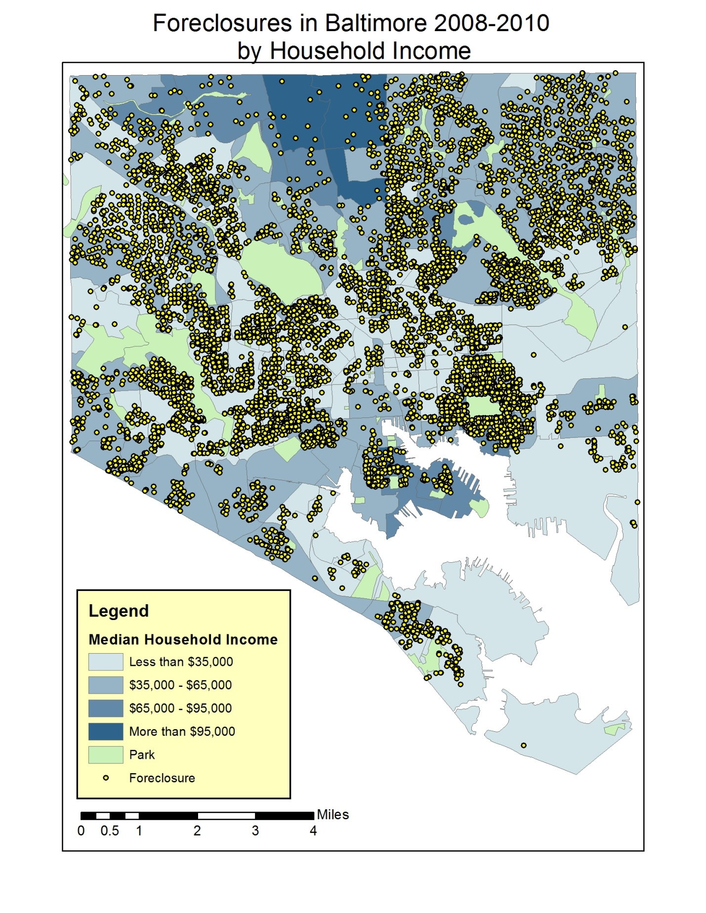

**Map 2b** shows the spread of foreclosures compared to the racial composition of the neighborhood. Foreclosures are clustered around Patterson Park and across majority-African-American neighborhoods in west Baltimore and east Baltimore

**Map 2b**

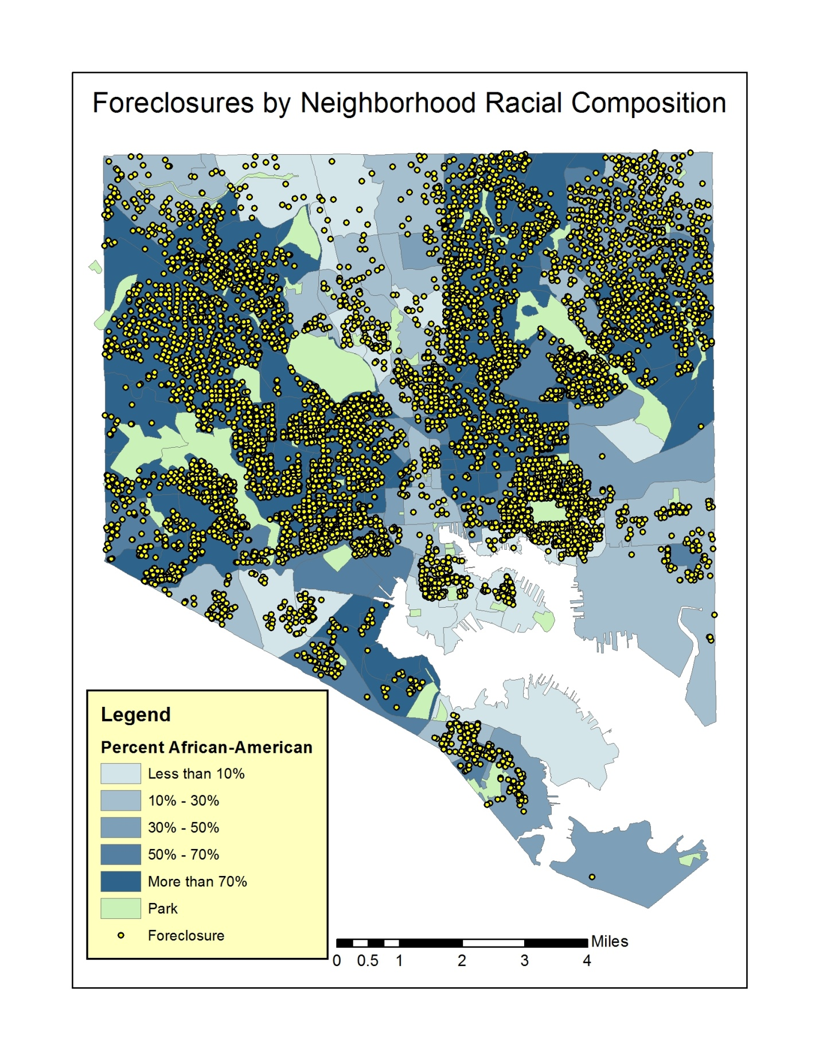

A close-up picture of the Patterson Park area shows that both Canton and the area north of the park were affected, with foreclosures on almost every block north of the park. The higher incidence tracks the racial composition of the area, with mixed race and concentrated African American neighborhoods taking the hardest hits.

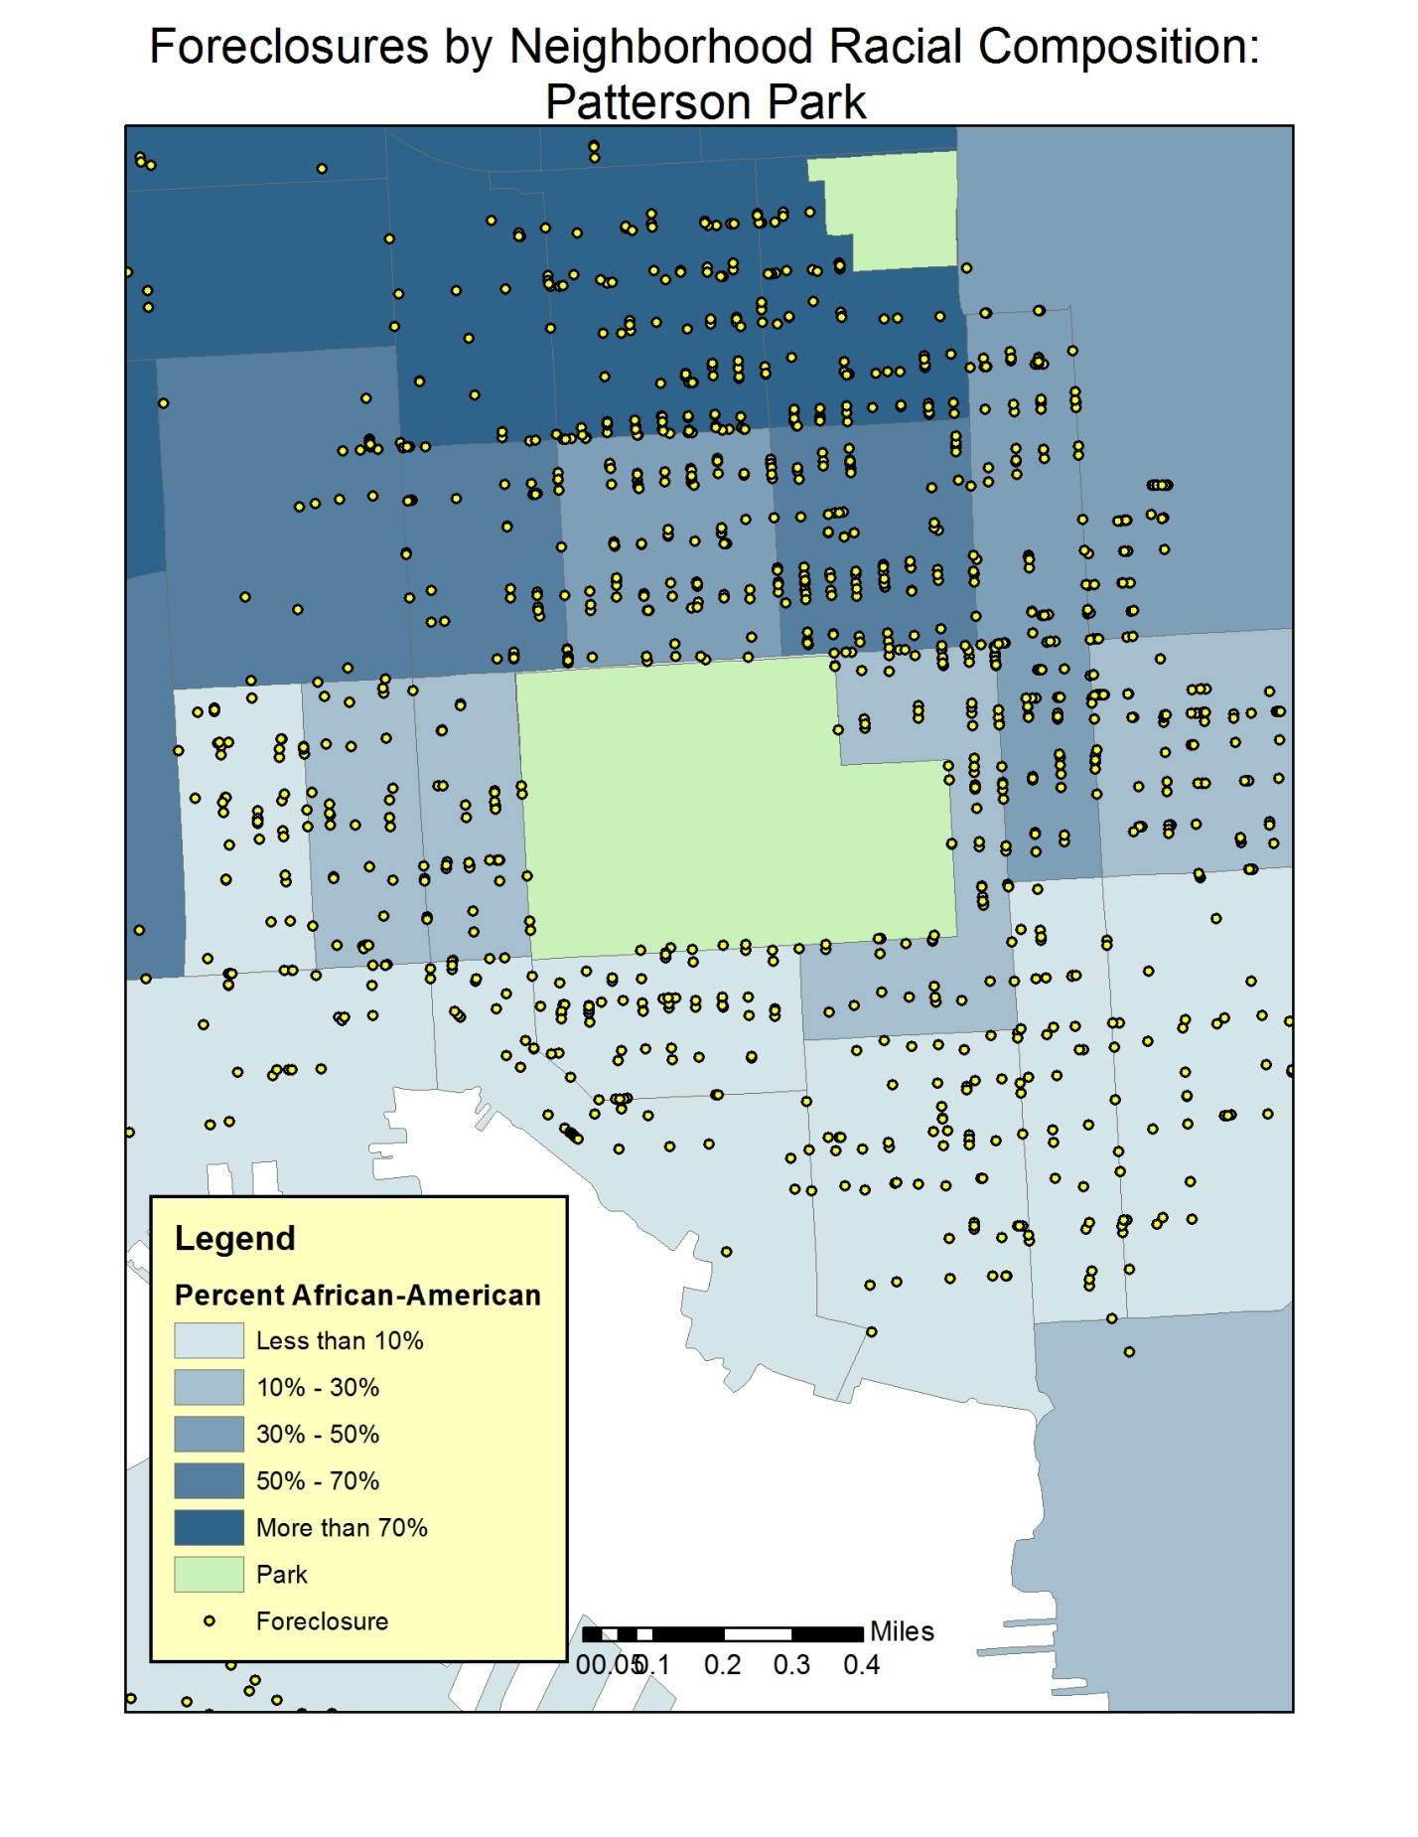

**What Did Foreclosure cost families? [3]**

**The financial impact of foreclosure varies by income, with the greatest losses mounting in the most affluent areas, but overall the “epidemic” has been very costly: the average family in the city of Baltimore lost almost $150,000 due to foreclosure.**

Not surprisingly, families in the wealthiest neighborhoods lost the most, since they had the most to lose in the first place. On average, high income areas lost $291,204 per foreclosure compared to $168,628 in middle class neighborhoods or $121,552 in working class neighborhoods.[4]Similarly, low-poverty neighborhoods had higher average losses than moderate or high poverty neighborhoods ($184,708 lost due to each foreclosure in the average low poverty neighborhood, compared to $145,254 in moderate poverty neighborhoods).

However, the average **middle class and mixed race neighborhood accounted for more total dollars** **lost**:

|  |  |  |
| --- | --- | --- |
| Income Class of Neighborhood | Average total loss in neighborhood | N (neighborhoods) |
| Working Class | $5,824,022 | 93 |
| Middle Class | $10,400,000 | 97 |
| Upper Class | $6,697,706 | 4 |

|  |  |  |
| --- | --- | --- |
| Racial Mix of Neighborhood | Average total loss in neighborhood | N (neighborhoods) |
| Majority White | $9,075,690 | 48 |
| Mixed Race | $9,769,773 | 40 |
| Majority Black | $7,126,917 | 106 |

This pattern is mostly likely accounted for by the fact that there were more foreclosures in middle class and mixed race neighborhoods than in wealthy and majority white neighborhoods—thus even though individual losses were lower in less affluent areas, there were more foreclosures in them.

**Altogether, foreclosures in the city cost Baltimore families $1.58 billion between 2008-2010.[5]**

**What Did Foreclosures Cost the City?[6]**

**As a result of foreclosures, the city lost an estimated total of $13.6 million in property taxes.** This estimate is probably low, since it does not take into account the negative impact of foreclosure on neighboring property values, which decline precipitously. Each foreclosure within an eighth of a mile of a home has been found to decrease its value by 0.9%.[7] The long term consequences of these reductions in the property tax base are hard to calculate, but almost surely lead to negative multiplier effects. If the city is forced to reduce services, property values may fall even farther, unemployment in the public sector may rise, and a new cycle of foreclosures can kick into gear. This “vortex” effect can be difficult to reverse.

**Conclusion**

The origin of the 2007 recession in the nation’s housing markets has had particularly devastating consequences for urban areas. Baltimore has experienced waves of foreclosures that have seen losses in equity and housing stability that have been especially hard on its mixed race, middle class and working class neighborhoods. These are the areas where a thin cushion of savings erodes quickly when unemployment strikes. The wealth loss sustained by these working families will be exceptionally hard to recover and may have consequences for decades to come as the savings represented by housing, which might have helped support the retirement expenses of the elderly or the college tuition of the younger members of their households, are no longer available.

The claim to the “American dream” that has long revolved around home ownership has taken a hard hit in Baltimore. The city itself has sustained a wound that will be hard to heal given the loss of wealth and the compounding loss of property taxes needed to support essential public services. It will take a sustained economic recovery and considerable investment to revive the neighborhoods affected by the foreclosure wave.

**TECHNICAL APPENDIX**

1. A note on class: We used the median household income (in 2009) in a census tract to measure social class of a neighborhood. We compared the median income in each tract in Baltimore to the median income in the average census tract in central Maryland ($65,000 in 2009). Tracts with a median income more than 1 standard deviation below the central Maryland average were coded as “working class,” while tracts with a median income more than 1 standard deviation above the central Maryland average were coded as “upper class.” Central Maryland is a good approximation of the housing market for the metropolitan area, and includes Baltimore City, Baltimore County, Howard County, Harford County, Anne Arundel County, and Carroll County. The class breakdowns for Baltimore city are as follows:

|  |  |  |
| --- | --- | --- |
|  | Neighborhood Median Income range | N |
| Working Class | Less than $35,000 | 93 |
| Middle Class | $35,000 to $95,000 | 97 |
| Upper Class | More than $95,000 | 4 |

We considered using the median income of the average *Baltimore city* neighborhood to make our class cut points, but this resulted in an income division that we felt was not representative of the wider concept of social class. For instance, the upper range of neighborhood incomes in Baltimore city (those more than 1 SD above the city mean) begin at $59,000, which is less than the average neighborhood income in the metropolitan area as a whole. We did not feel that designating these neighborhoods as “upper class” would be consistent with the wider use of the term. Our class breakdown (outlined above) results in fewer “upper class” neighborhoods, but is more representative of the divisions in the metropolitan area and Baltimore’s social class composition relative to the rest of the state. Because our measure of foreclosure incidence is not a total count, but is normalized according to the number of houses in the neighborhood, it is not influenced by the different number of upper class and middle or working class neighborhoods in the city.

1. Estimating property taxes: We linked individual addresses in our foreclosure database to the Maryland Department of Assessments and Taxation (<http://www.dat.state.md.us/>) , which provided us with the assessed value of the foreclosed property. Ideally, we would have done this for every property in our database—but because the properties had to be looked up individually, this was not feasible for the amount of time and manpower we had. Instead, we chose a single property from each census tract in the city. We chose the property that had the median foreclosure loss in the tract—this is not a perfect match for median assessed value, but it is a better proxy than choosing a property at random. We then used that assessed value to represent the assessed value of every foreclosure in the tract. We then multiplied the assessed value by the Baltimore city property tax rate (2.268%), to derive the amount of property taxes lost on each foreclosed property. The total amount of property taxes is provided above ($13.6 million).

This analysis is for 2010 only, because the Department of Assessments and Taxation database contains the most recent property tax assessment, which in many cases was done in 2010—it would therefore not be representative of property assessments in 2009 or 2008.

1. Count of Foreclosures: Some of the properties in the database are commercial or industrial. We had no way of identifying them in the data, but came to this realization as we looked individual properties up on the Assessment and Taxation website. In our analysis of incidence and loss amount (Sections 1 and 2, above), we excluded all properties where the foreclosure amount was greater than $1 million (285 total cases out of more than 11,000). This limits our analysis to the properties we believe to be homes. The analysis in Section 3 includes properties where the amount of foreclosure loss was greater than $1 million, because the city would still lose property taxes as a result of foreclosure on these properties. In an alternative calculation, we dropped all properties where the foreclosure amount was greater than $1 million—the calculation of property tax loss was $11.5 million in 2010.

1. The data do not allow us to determine whether or not a foreclosure filing led to an actual foreclosure. Using the Baltimore Neighborhood Indicators Alliance data base, we use the filings to approximate the incidence and cost of foreclosures in the city.
2. We could not retrieve data on foreclosures that took place in the first two quarters of 2009. Thus the analysis presented here likely underestimates the number and impact of foreclosures on the city as a whole during this time period. However, there is no reason to believe that the pattern of foreclosures would differ in the first half of 2009—thus the calculations that follow likely representative of the impact of foreclosures on different kinds of neighborhoods in the city throughout the period in question.
3. Financial Loss is calculated from the amount of the lien reported in the foreclosure filing for each address. The calculations in this section assume that all foreclosure filings went to foreclosure.
4. Average losses were higher in white neighborhoods ($221,134) than in mixed race or black neighborhoods ($151,646 and $125,678 respectively)
5. This calculation does not include foreclosures that occurred in the first or second quarter of 2009.
6. Please see Technical Appendix for more on our property tax loss estimate.
7. Dan Immergluck and Geoff Smith, 2006. “The External Cost of Foreclosure: The Impact of Single Family Mortgage Foreclosures on Property Values,” *Housing Policy Debate* 17(1) : 57-79).